James Keller – GES408 – Week 7 Lecture Activity

State your null/alt. hypotheses for ANOVA: Does canopy type affect the amount of leaf mass lost? Make sure your hypotheses are measurable/testable. (1 point)
Null: There is no difference in the average amount of leaf mass lost between different canopy types
Alternate: At least 1 canopy type has a different mean amount of leaf mass lost than the rest
State the mean mass loss associated with each of the three canopy types. (1 point)
Edge: 2.119g
Gap: 3.080g
Interior: 1.239g
- Conduct a one-way ANOVA.
- Go to ANOVA → Classical ANOVA
- Set:
- Dependent Variable = Mass_Loss_g
- Fixed Factor = Canopy_Type
Check the assumption of homogeneity of variance. Is the assumption met? How do you know? (1 point)
The assumption is met and we can tell because our p-value for our homogeneity check is 0.914 which means that our data does not significantly vary from the expected homogeneity.
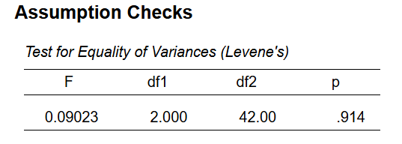
Report the f-statistic and the p-value of your ANOVA. What conclusions can you come to regarding your hypotheses (accept/reject)? Be sure to explain what the results of your ANOVA mean regarding the means of your groups. (2 points)
The f-statistic is 763.8 and our p-value is less than 0.001. From this, we can reject our null hypothesis and can conclude that at least one of our groups is significantly different from the rest of the groups.
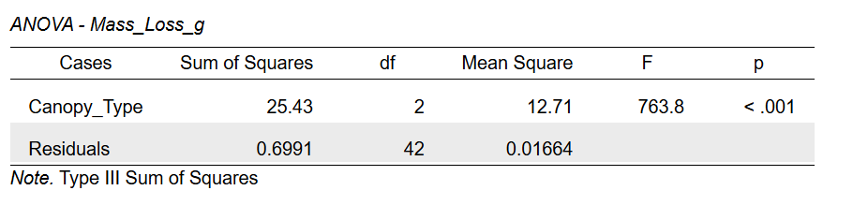
If your ANOVA is significant, perform a Tukey HSD post-hoc test, and report the results, making sure to state what the results mean in terms of group similarities or differences (if it is not significant, state that as well.) (1 point)
Our Turkey HSD test gives significant p-values for Edge-Gap, Gap-Interior, and Interior alone. This means that all 3 groups differ from each other significantly.
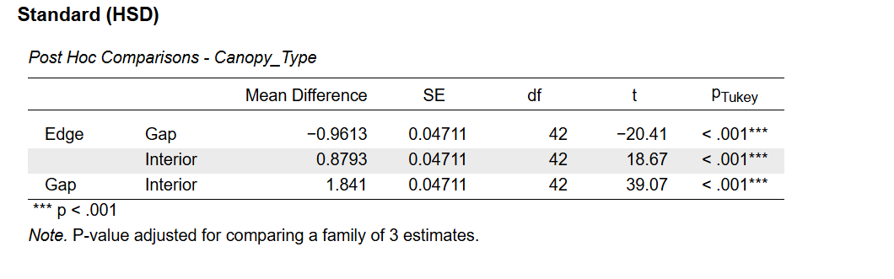

Create and display a bar plot with error bars (standard error) comparing the three treatments. (1 point)
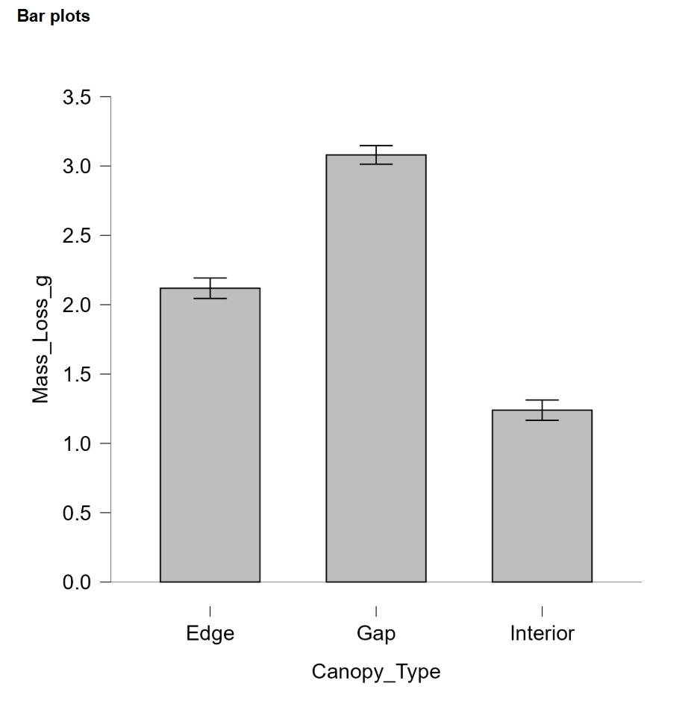
Experimental design: How would you redesign this experiment (or what data would you collect) to test decomposition over time / obtain the decomposition rate? (1-2 sentences) (1 point)
I would redesign this experiment to collect data at several time intervals. Along with the canopy type and bag id, you would also collect how many weeks it has been since the bag was filled.

